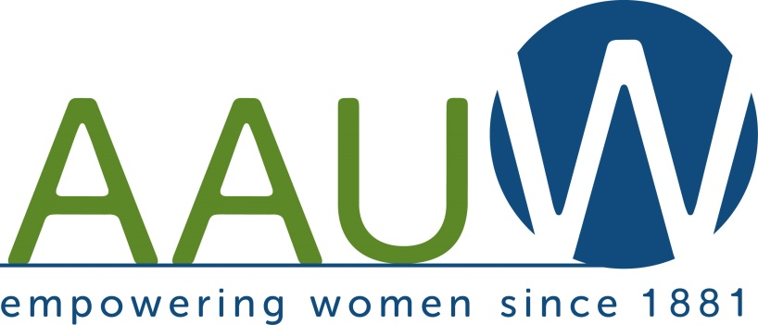

The Anacortes Agent

Volume 31 Number 3 ……………………………………………………………. November 2014

**Thursday, November 13 ~ BOOK TALK Here’s a fun way to get to know others and pick up some recommendations for your reading list.** Each member is asked to select a book on the chosen subject and we ‘circle up’ and briefly summarize the book and why we chose it. Linda Hendrick facilitates the discussion with lots of fun quotes. Here’s why she decided on **‘The Sea’** as our featured topic. “Anacortes is a sea town. We are surrounded by water, the sea is our town's history and many of us spend time near or on the water.  Books about the sea abound.  There are histories, scientific treatises, and exciting adventure stories. From Homer to Hemingway-Douglas there is a book you will find interesting, riveting or just plain fun.

**Presbyterian Church Fellowship Hall at 9th & M at 7:00 p.m.**

Parking is available behind the church. Enter through alley door with access by stairs or elevator.

Your commitment to AAUW makes membership more meaningful….

Each month our branch has a **STEM** table filled with books just waiting to go home with you! There are several ways you can help support this. First, you can **Donate** books for the table. They should be in good condition and something you feel others would enjoy reading. Or, you can **Select** books to take home. For a $1.00 donation you can pick up a book recommended by a fellow member. Also, you can **Keep it current**. We have quite a few books on the table that have been there for a while. Won’t you help us keep the table fresh and inviting by removing any books you donated that have not sold to make room for new selections.

**Thank you for supporting STEM.**

**DIRECTORY CHANGES**

Vivian Kolhoff has a new phone number~ 755-3564 Use this cell number for Cordelia Hightower ~ 206-313-6537



Peggie Hunnicutt (11/6)

Judith Rolston (11/7)

Bunny Heiner (11/10)

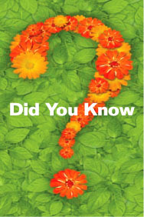

During the occupations of World War II, AAUW assisted European women scholars whose lives were at risk: AAUW members helped [find academic positions for these students and professors in the United States and other countries](http://www.aauw.org/2013/03/14/einstein-aauw-jewish-women-scientists/). Following World War II, AAUW continued its commitment to cooperation through participation at the Bretton Woods Conference and the United Nations. Today, AAUW continues to advocate for women and girls in a variety of ways.

When a woman is educated and empowered, she starts a ripple effect in her community. This is true all over the world. But women still face barriers that keep education and security out of reach. Only through community support and access to resources like education, health care, and career opportunities will women have the chance to succeed. That’s why AAUW has [given fellowships](http://www.aauw.org/what-we-do/educational-funding-and-awards/international-fellowships/) to more than 3,000 women in 134 countries and why we regularly speak out on behalf of women and girls [at the United Nations](http://www.aauw.org/what-we-do/global-connections/international-coalitions/united-nations/) and in critical [global coalitions](http://www.aauw.org/what-we-do/global-connections/international-coalitions/).

Here’s how you can be involved…

Barbara Lewis needs a **Co-Chair** to assist with **Publicity**.

She has the contacts, but could use some help with monthly publicity.

Contact Barbara at [barbara.lewis@wwu.edu](mailto:barbara.lewis@wwu.edu) or call her at 333-8018

A **Chairperson** is needed for our **Spring Scholarship Event** in April of 2015.

This is a well-oiled machine, but it is so valuable to have one person overseeing the operation.

You can expect help from previous committee heads and board members! If you are willing to step into this leadership position or have an idea for a speaker, please contact

Linda ([hend244@gmail.com](mailto:hend244@gmail.com)) or Rosette ([rdawson53@comcast.net](mailto:rdawson53@comcast.net)).

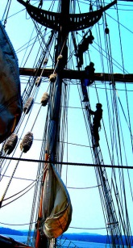Thirty four years ago commercial fisherman sold their used gear as yard art on Commercial Avenue. Shipwreck Days has evolved into a massive community garage sale. Organized by Fidalgo Island Rotary, this annual July event provides a great opportunity for us to do some easy fundraising. Begin now to set aside items for **Shipwrecked Days 2015**. We are planning to have a booth there and hope to raise additional funds for Tech Trek and NCCWSL, also known as the National Conference for College Women Student Leaders. As America’s premier conference for college women, the conference provides a transformative experience for attendees and prepares them to be the next generation of leaders. Each attendee becomes a part of the 29-year legacy of the conference.

**Please consider setting aside those small treasures around your house that would make a great donation.**

**Get to know a little about Corinne Salcedo….** I think what I've become in my retirement is somewhat of a local activist.  This time of year I'm on the campaign trail, as usual.  I'm working with the I-594 campaign to expand background checks for gun sales beyond the current requirement of sales thru licensed dealers.  594 would, additionally, require checks for online sales and private sales.  I believe closing those loopholes would reduce the murder rate, the suicide rate, and the number of gun injuries.  So I've been organizing phone banks for 594 here, and we're having a second doorbelling event here in town on Sat., November 1st at 1:00 pm.  At this point we're calling on supporters and asking them to turn in their ballots.  Do call me at 293-7114 if you'd like to join us!  
  
I haven't been very active in AAUW lately, but right after I joined, I was asked to co-chair the tea with Carol Bergner.  Because it was to celebrate the 50th year of Anacortes branch, we enlisted Pat Bell with her historical knowledge, as a third chairperson.   The three of us wrote a skit about the history of notable Anacortes women and got others to act it out.  It was a wonderful experience, and I was proud of our effort.  After that I served as secretary for 2 years, and didn't miss a single board meeting.  Then I was scholarship co-chair for 2 years.  I value AAUW not only for its mission, but because I've made some wonderful friends through our branch.  Thanks for your friendship!

**A note from a Scholarship Recipient**



Dear Anacortes AAUW,

Thank you so much for your generosity in providing me with a scholarship. I am very appreciative and honored to have received it. I just began the second semester of my Doctor of Physical Therapy program at University of Utah. This semester I have a full course load and am working part time at a physical therapy clinic run by two of my professors. I work with patients who have had strokes and assist them in their rehabilitation programs. It has been a great learning experience and I really enjoy working there. I was also elected Vice President of my class last week, so I will be involved in the organization and planning of several class events.

My first semester, which took place last summer, was difficult, but fascinating. I took an anatomy class, pathophysiology class, and most interesting of all, cadaver lab. Cadaver lab was challenging and took some getting used to, but turned out to be my favorite. Class. It made understanding what we were learning in anatomy so much easier and it was amazing to have hands on experience with the human body. On the weekends, I spent my time studying and enjoying all that the Salt Lake City area has to offer, including hiking almost every weekend. I am extremely happy with the program. My professors are experts in their fields and are extremely supportive of their students. I am so excited to be here and thank you again for your support of my continuing education. I hope to check in again soon and please feel free to contact me with any questions! I will be home around Christmas and would love to meet you all in person, if possible. Go Utes! Best, Casey Anderson

**Next Board meeting will be held in classroom 3 of the Presbyterian Church at 9th and M on Monday, November 3, at 7 P.M. All are welcome to attend.**