

**Anacortes Agent**

Volume 35 Number 12

August 2018



Over $850 was collected for LAF at the barbeque held at Lonny and Bunny Heiner’s home. Tasty treats were enjoyed by all … watch for more pictures in the September edition of the newsletter.

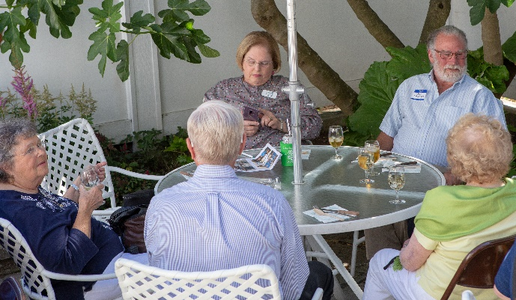 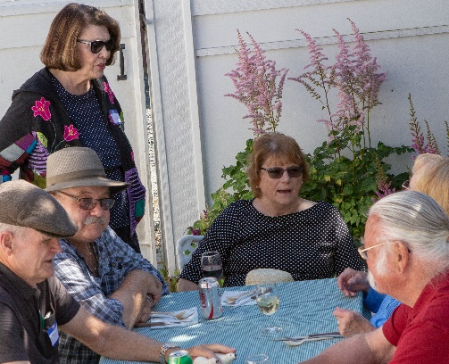

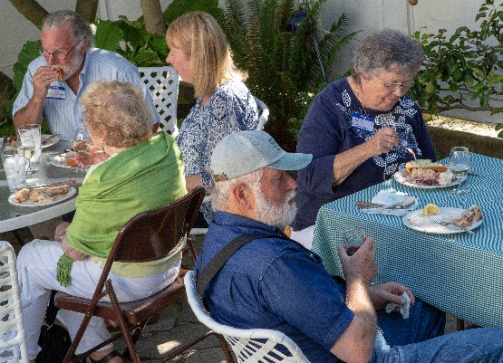

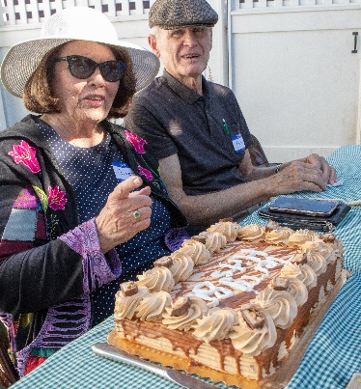

If you are new to the Anacortes Branch of AAUW or feel your current directory photo no longer looks like you, contact Lonny Heiner at [leheiner@gmail.com](mailto:leheiner@gmail.com) for a photo appointment. The new directory comes out in September. If you have new contact information, please tell Bonnie Underwood at 360-293-4075 or [underwood31@comcast.net](mailto:underwood31@comcast.net)

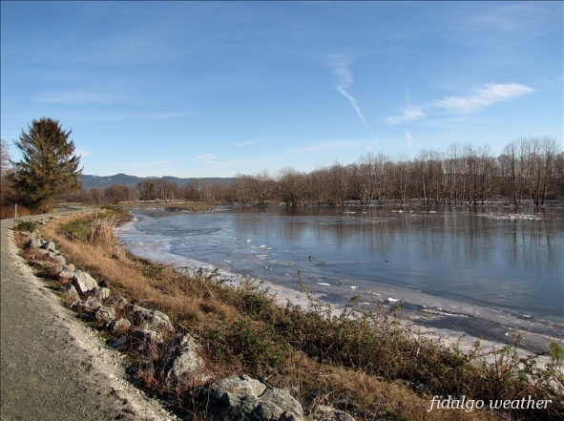

Linda Hendrick is planning a walk at Wiley Slough.  It would be a half mile to a mile and a half walk along a slough outside Conway.  Parking does require a Discovery Pass so carpooling is encouraged.  Following the walk, members will lunch at the Conway Tavern and/or a stop at Snow Goose for ice cream.  If you are interested, Linda is collecting names and will provide some dates as soon as she knows who is interested. You can contact her at [hend244@gmail.com](mailto:hend244@gmail.com).

Margaret Frey is moving from yahoo to gmail. Her new email is [catsswiss2018@gmail.com](mailto:catsswiss2018@gmail.com)

Nelle Jacobson has changed her email from wavecable to gmail: [nelleadyj@gmail.com](mailto:nelleadyj@gmail.com)

Bonnie and Mike Underwood have moved to

1406 8th Street, Anacortes

**BOARD RETREAT**

**Monday, AUGUST 27, 10:00 A.M.- 4:00 P.M.**

**A potluck dinner and planning retreat for all officers and chairwomen at the home of Robin Pestarino, 801 E Avenue, Anacortes**

**RSVP to Robin at 360.588.8177**

An agenda and packet will be mailed to officers prior to the retreat.



Our AAUW branch will have a booth at the Anacortes Farmers’ Market on August 25th and September 15th. Volunteers are needed to host the booth. This has proven a great way to meet potential members and let our community know what AAUW contributes. The booth includes lots of wonderful posters showcasing Tech Trek, Scholarships, Jingle Bell Dash, and member activities. Won’t you contact Bunny Heiner at 360-293-4120 and volunteer to serve for a couple of hours?