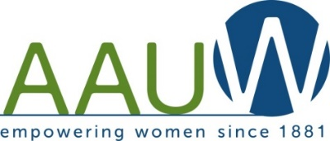

**Anacortes Agent**

Volume 35 Number 5

January 2018



**Learn about Affordable Housing from the Anacortes Housing Authority**

Join us for a presentation by Brian Clark, Executive Director of the Anacortes Housing Authority, on Thursday, January 11, 2018. The program begins at 7:00 p.m., with refreshments and hospitality offered at 6:45 p.m., in the Friends of the Library Community Room. Topics will include the history and role of the Housing Authority in providing a variety of safe and affordable housing options in Anacortes, processes and requirements for individuals and families to qualify for available housing, and current hot topics being addressed by the Housing Authority.

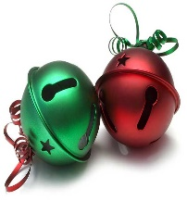 **HORRAY!!!!!!**

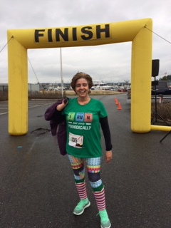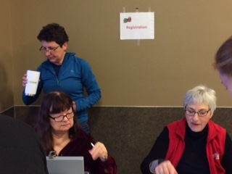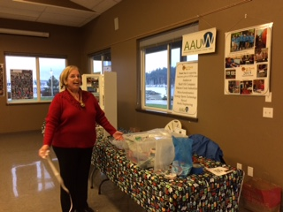Over $6,000 was made at the Jingle Bell Dash fundraiser in December. Proceeds will fund STEM programs in 2018. Many thanks go to the volunteers who helped with registration and those of you who brought goodies for the runners. We were pleasantly surprised to see former member, Vildan Kirby, who ran the 10K race! Once again, Lonny Heiner was stationed at 8th and “K”, taking

photos of the runners as they passed by on the route.

John O’Clock made a jolly Santa for the Kids Dash

and we are thankful to Gere A Deli for donating hot chocolate and coffee.

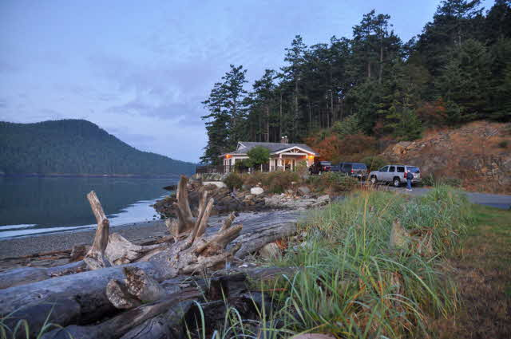A lovely evening was enjoyed at our December Holiday potluck at the Skyline Cabana. Warmed

by good company and a toasty fire in the fireplace, we dined on a variety of delicious potluck dishes. Thankfully, the board agreed to hire someone to clean-up according to Cabana policy, and we were all able to leave the event early! Special thanks go to Jo Ann Satzinger for making the arrangements.

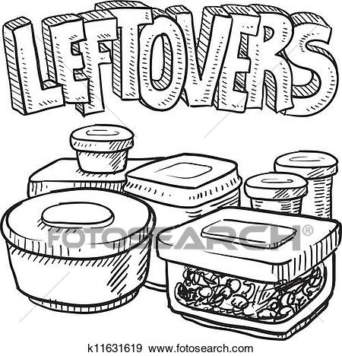

Bunny Heiner reports that there are two mugs left-over from the AAUW party, along with two tablecloths from the cookie table, and two large white dinner plates (restaurant grade “china”) which someone brought with cookies for the JBD.  Laura Jane Viverette came home with someone’s spoon from the potluck. If any of these things belong to you, please contact Bunny or Laura Jane.





The January board meeting will be held on Monday, January 8, 7:00 p.m.

Westminster Presbyterian Church, 1300 9th Street, Classroom 3

Our February meeting will include a panel of speakers on Title IX



Our Spring Tea will be held at the Anacortes Senior Center on Saturday, March 24. We have confirmed Lara Dunning, a local blogger, as our speaker. A chair for the tea is still needed.

Our April meeting will be on the topic of Historical Trauma and Cultural Healing.

**AAUW Anacortes Branch Board Members**



Our branch depends on all of you. When you joined AAUW, you made a commitment to the mission of AAUW. This is an exciting time for our branch. We are growing our fundraising efforts and expanding our STEM programs, but we can’t continue to expect the board to do all the work. Please know that you make a difference. Attend the meetings, join a committee, become a chairperson, volunteer. We need your experience, your ideas, and your enthusiasm. With a membership of 45, we should have more than 10-12 members attending a meeting. Please join us on January 11.