 

**Anacortes Agent**

Volume 36 Number 2

October 2018

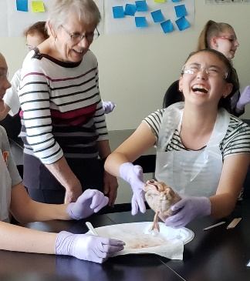

Pictured here is Jessica Koeberle, a member of our branch and the Whidbey Island branch. She visited with Tech Trek students this summer. This is the meeting where we hear from students who attended camp.

**Thursday, October 11**

Coffee and conversation start at 6:45 and our program begins promptly at 7:00 p.m. A brief business meeting will follow the program.

Our new meeting place is the **Community Room of the Anacortes Housing Authority** behind the Harbor House at 719 Q Avenue. If you use the one-way entrance off Q Avenue, between 7th & 8th, there are a few parking spots available. Other parking will be off street, either on Q Avenue or R Avenue.





Jingle Bell Dash update

The application for the grant (sponsorship) from Andeavor has been submitted. Beth has requested $4,000 this year, to cover costs of chip timing.  The event has been created on Facebook, the website is up to date and registration is up and running. The cost for adults has increased this year, but we are maintaining a low price for children under 18. The ball is rolling! Save the date – December 15th.

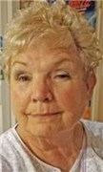



We are sorry to report the passing of former member, Carol Bergner. Her husband Don contacted member Corinne Salcedo to let her know Carol died at Virginia Mason on the September 14 of liver failure related to advanced liver and pancreatic cancer. Corinne shared that it was Carol that invited her to join AAUW and hosted several gatherings for prospective members. Pat Bell, Carol and Corinne co-chaired the Tea for the 50th anniversary of our branch and Carol was one of the tap dancers at a more recent Tea featuring Fidalgo DanceWorks. A card has been sent on behalf of AAUW to her family.

Many thanks to Mayor Laurie Gere for sharing her story with us at the September meeting. The meeting was well attended and we are grateful to those who brought treats to go along with coffee for the meeting. Program Co-Chairs, Tanna Baker and JoAnn Satzinger, got us off to a good start!

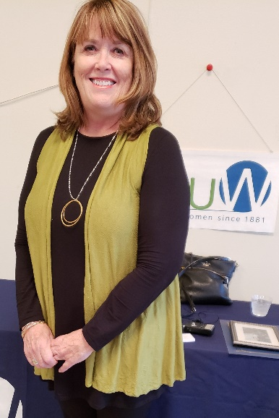 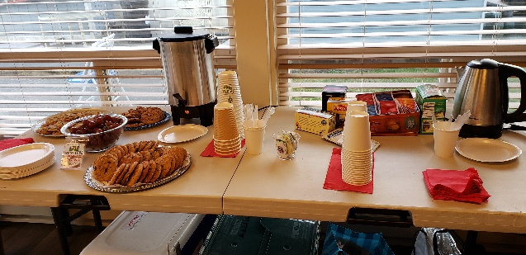 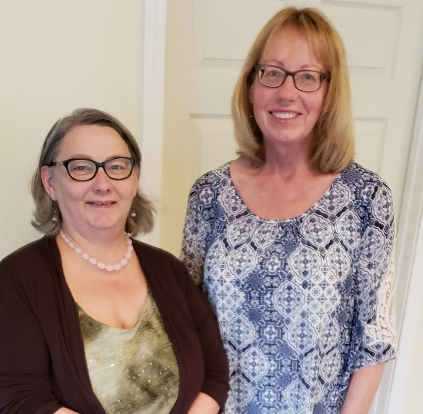

***Membership Co-Chair, Bunny Heiner, reports on the recent Farmers Market booth hosted by AAUW.***

Once again, thank you so very much, everyone, for all your work in making our second membership drive at the Farmers Market such a success.  We had our final drive on Saturday, the 15th of September.  Having learned from our initial drive on 25 August, we did not start this time until 7:30 a.m.  Rosette and Homer, Ginny, and I were there to set up and got everything done.  Despite the rain that day, we had a steady flow of “customers” and are glad to report that we have two new members:  Sara Holahan and Jean Miller, and a possible new member, Renee Shain). Three people signed up for the Jingle Bell Dash.

Many thanks to Robin for providing the canopy, which was very much appreciated when it started to rain, and to Rosette and Homer for providing the table; thanks again, Rosette, for the posters and that attractive AAUW tablecloth.  Also helping out this time were Sandy Huggins and Barbara Gaffney.  And, of course, many thanks to Santa Claus!  Our Santa, John O’Clock, was accompanied on his rounds by “elf” Sandy.  They reported a good interest and handed out a number of information/sign-up sheets. Homer returned at the end of the day and helped with the take down.  He not only loaded everything into their van, but helped me set up all the components of the canopy in our garage to dry.  With the load in the van, I was very glad to get a ride home from Ginny.

One of the nice side benefits of doing this membership drive is the chance we “booth sitters” have to visit together.  And once again, thanks to “booth sitters” Ora, Linda, and Megan for their help during the earlier membership drive. Many, many thanks, one and all.



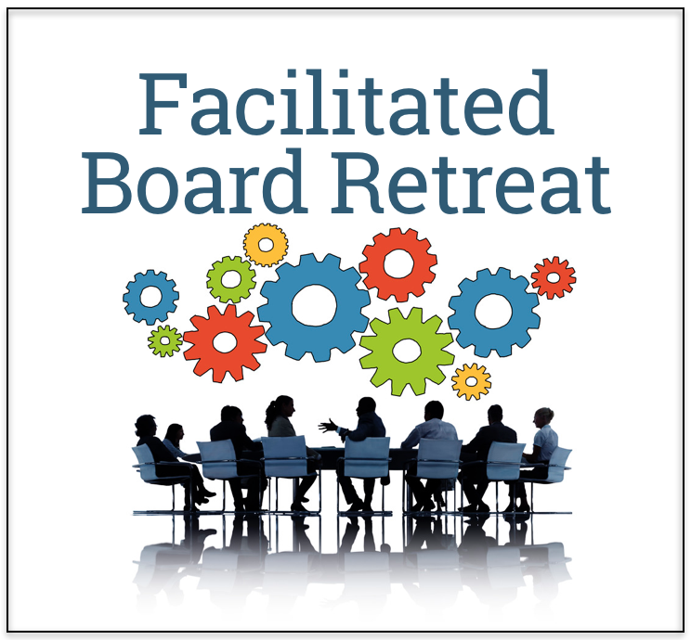**Minutes from the** AAUW Anacortes Board Retreat on August 26, 2018 at the home of Robin Pestarino

Present: Rosemary Kaholokula, Secretary, Ginny Kluth, co-VP for membership, Bunny Heiner, co-VP for membership; telephone tree, Rosette Dawson, fundraising chair, Terri Bawden, scholarship chair, Robin Pestarino, president, Linda Hendrick, financial officer, Megan Taylor, financial officer, Ora Jonasson, nominating committee chair, JoAnn Satzinger, program co-chair & publicity, Tanna Baker, program co-chair

Meeting called to order 10:12

Reviewed minutes of 8/26/17 board retreat

Item not yet accomplished from 8/26/17 goals:

Website

Discussion on whether we should pay AAUW to host our website and keep it updated for us. If we go that route, we would still need a webmaster in our club to send information to AAUW for purposes of keeping our club website updated. It will cost some money for national to host our site, but it could be worth it. There was some discussion on whether the national AAUW web platform might be too limited. We need the site to be able to list the meetings that our club is having. President Robin indicated that her priority is to get our local site updated and running.

**Action Item: Linda** will call and find out the cost for national to host our site.

Financial Report

Reviewed the 8/27/18 financial report by Linda

21 members’ dues were deposited with debit card

But this is difficult to keep track of things and we want all members to pay their own memberships through the website next year

Discussion re AAUW- Anacortes Branch STEM and should that amount be $3177.50 and not $6,177.50 since 2 STEM checks have been cashed.

Motion to accept report- Bunny (with the AAUW – Anacortes Branch STEM changed from $6,177.50 to $3177.50)

Second – Ginny

Passed

Fundraising - Rosette

Reviewed Income and Expenses (scholarships + expenses)

Rosette talked about the usual institutional donors who give

We usually get about $16,000 for Tech Trek

Beth usually nets about $4,000 from the Jingle Bell Dash

We need a financial report from Beth on this fundraiser

**Action Item: Robin** will contact Beth

We have (3) $1,500 scholarships for a total of $4,500

We have (4) $100 8th grade awards for a total of $400

Fundraising - Terri

Terri: fundraising idea

Goal $5000 a year

For a $2000 and 3 more $1000 awards

Grocery/Tote Bag fundraiser proposal

Motion made – do Terri’s idea and have the money come out of the savings account #6780

Linda moved

Tanna second

Discussion

Motion restated:

Robin: use $3500 from account #6780 in order to fund the grocery tote bag fundraiser. Once 1,000 bags are sold, we will reimburse that account 2500 which means that 5500 will go to scholarship account.

Discussion

(Megan arrives)

Robin’s motion: We will use $3500 from account #6780 in order to fund the grocery tote bag fundraiser. The first $2,500 net proceeds will reimburse account number 6780. All additional net proceeds will go to the scholarship account.

Bunny seconds

Passed

Review of membership directory

Bunny asked for input on several things for the membership directory

Nominating Committee Report (Ora)

Current committee positions that are filled:

By-Laws – Nelle Jacobson

Communications – Bonnie Underwood

Fundraising, Tech Trek - Rosette Dawson

Fundraising, STEM - Beth

Fundraising, Scholarship - Terri

Nominating – Ora Jonasson

Phone Tree – Bunny Heiner

Program Planning - JoAnn and Tanna

Public Policy – Claudia Cimini

Scholarship – Terri Bawden

STEM – Beth Meenaghan

Social Media - Claudia Cimini

TLC – Polly is currently doing, Ora volunteered to fill if Polly doesn’t want this anymore, **action item: Terri** will check in with Polly

Vacancies:

Current vacancies that need to be filled:

Historian

Publicity

Website Manager

For 2019 - 2020

President

Treasurer

Co-VP for programs

Nominating Committee

Fundraising

We will do the tea on March 30. Space is reserved the night before, the 29th, 5 to 7, and on the 30th, 1 – 5.

LAF fundraiser

@ Lonnie and Bunny’s on 8/17/19

Membership report

48 paid members

Lost 2 members

6 new members

Financial officers report - Budget

Increase the budget for speaker stipends to $400.

Add a “hospitality” line and budget $400 to cover our meeting items and any party food

Tea program/presenter – will keep at $50

“Writers Forum” - - eliminate as a line item

Robin concerned about items being sold for fundraising – maybe we need a line item for sales tax

Terri - Fund raisers may be exempt unless it’s a regularly recurring business

We discussed that the budget needs revision – some things aren’t reflected in there, for example, the scholarships that we give are not listed nor are the institutional donations.

Need to account for the grocery bag fund raiser in the income and expenses of the budget

Income = $8000 in bag sales + $2000 in ad sales

Expense = $3500 to make bags + $680 sales tax

Budget is tabled until next meeting

**Action Item:** Budget revision

Issue of whether raising membership dues for ’19-‘20

We discussed the issue in May and tabled it

We need to talk about it this year

When comes up for vote in May, want to be able to talk about it beforehand

Rosette feels that we need to increase the dues – right now we only get $11 per person, whereas we used to get $21

We feel we need the $21 per person

We need to provided information on this issue to the membership

Calendar for ’18-‘19

Board meetings at Westminster Church, 1300 Ninth, at 7:00

General meetings and programs at Community Room, 719 Q Ave (park on R)

September 13: Laurie Gere; general meeting

October 1: Board Meeting

October 11: Tech Trek presentations; general meeting

October 29: Board Meeting

November 8: Book Talk – Award Winning Books; general meeting

December 3: Board Meeting

December 13: Holiday Party

December 15: Jingle Bell Dash

January 7: Board Meeting

January 10: TBD; general meeting

February 4: Board Meeting

February 14: Dawn Harju – compassionate communication; general meeting

March 4: Board Meeting

March 14: STEM Recognition & Scholarships Speaker; general meeting

March 30: Tea fundraiser

April 1: Board Meeting

April 11: Mary Lou Sanellis performance and discussion; general meeting

April 29: Board Meeting

May 9: Annual Meeting

August 17: LAF Fundraiser

Goals for 2018-19

Additional fundraiser – tote bag

If is successful, maybe can eliminate tea fundraiser

Increase membership

Meeting adjourned 4:00