

**Anacortes Agent**

Volume 36 Number 1

September 2018



**New meeting place**

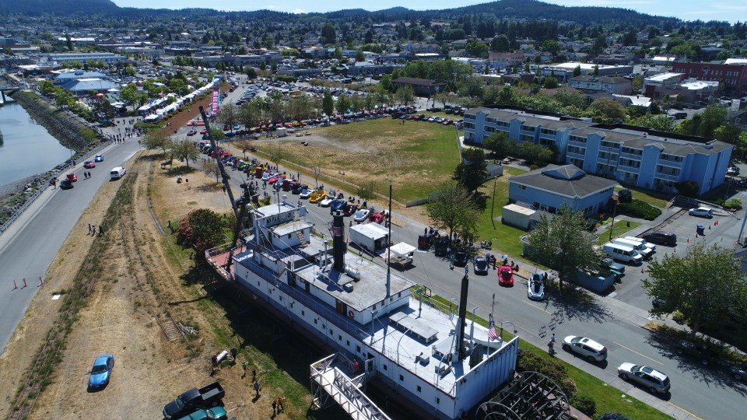

Join us for our first meeting of the year at the Community Room of the Anacortes Housing Authority behind the Harbor House at 719 Q Avenue. If you use the one-way entrance off Q Avenue, between 7th & 8th, there are a few parking spots available. Other parking will be off street, either on Q Avenue or R Avenue.

Parking

Parking

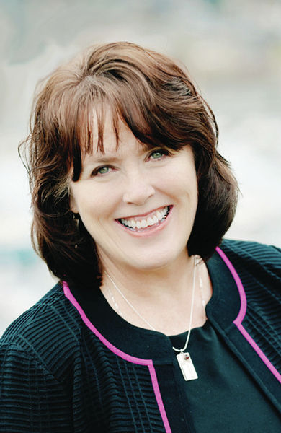

At the September 13 meeting of AAUW, Mayor Laurie Gere will reflect on the adventures and accomplishments of her life and will share her keen observations about personal development, family, business, and civic engagement. Coffee and conversation start at 6:45 and our program begins promptly at 7:00 p.m. A brief business meeting will follow the program. This meeting is open to the public, so invite your friends and neighbors.

Directories will be available at the September meeting. Directories include meeting information and dates as well as contact information for all members. If you are unable to attend, please ask a fellow member to pick one up for you. They will be available at meetings unless you request that it be mailed.

**Anacortes Branch**

**2018-2019**



Board Retreat

Ora, Linda, Bunny, and Terri

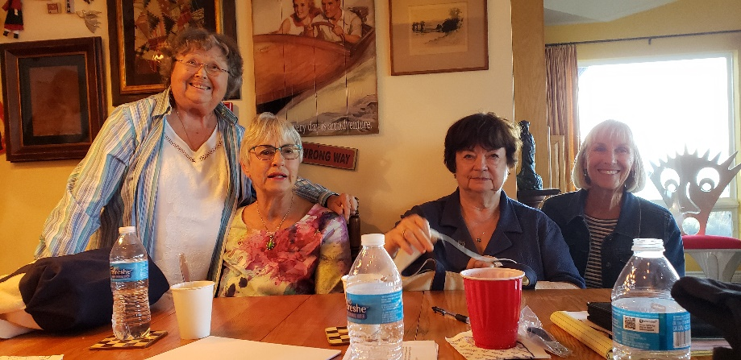

Rosette and Megan

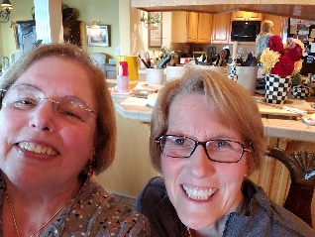

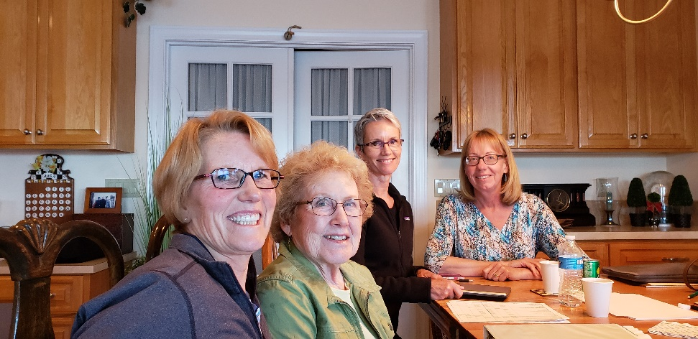

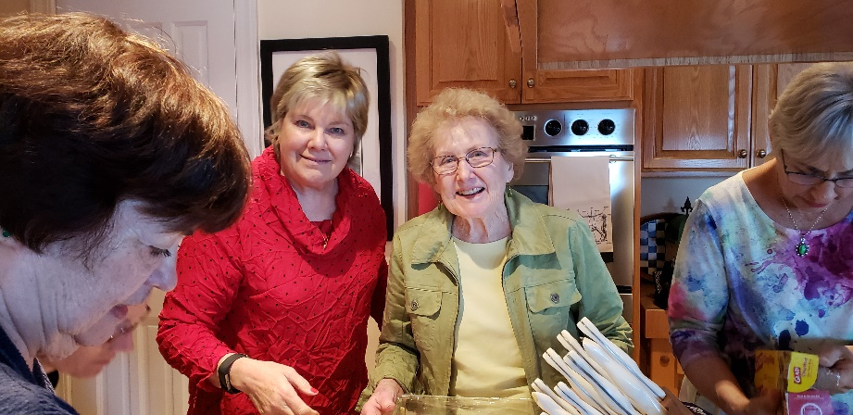

Megan, Ginny, Rosemary, and JoAnn

Robin and Ginny

On August 27, board members met at the home of President Robin

Pestarino to plan for the upcoming year. This all-day event coordinated our program calendar, speakers, fundraising ideas and events. We are grateful to Robin for hosting the retreat as well as providing leadership.

**Where will you serve?**



Being a board member is a wonderful opportunity to become more involved in AAUW. Below is a list of currently vacant positions. Please contact Robin ([rpestarino46@hotmail.com](mailto:rpestarino46@hotmail.com)) if you are interested or want more information. Detailed position descriptions are available and mentoring by former volunteers is encouraged. Gone part of the year? Think Co-Chairs! Ask someone to join you and job share.

* The role of branch **Historian** is in transition. We have many scrapbooks that include memories about events, news articles, and members. How shall we preserve and share this history for future members?
* The **Hospitality** Chair oversees finding monthly volunteers to host coffee at our meetings and maintains the items needed to do that. Once a year, Hospitality helps with the Holiday Party.
* **Publicity** is essential to communicating with the public, encouraging membership growth, and fundraising. A well-organized list of how to contact the various agencies and organizations is available. You will coordinate with our Program VPs for current information.
* **Website** management is an area currently under discussion. We may decide to coordinate with the national website, but if you have a talent in this area, the board would be grateful for your input.
* **Spring Tea Chair** provides leadership for this annual event; a theme and speaker are selected by the chair, with suggestions from the board. There are many veteran volunteers for this event!



Our AAUW branch will have a booth at the Anacortes Farmers’ Market September 15th. Volunteers are needed to host the booth. This has proven a great way to meet potential members and let our community know about the mission and contributions of AAUW. The booth includes lots of wonderful posters showcasing Tech Trek, Scholarships, Jingle Bell Dash, and member activities. Please contact Bunny Heiner at 360-293-4120 to volunteer to serve for a couple of hours. Read about the last Farmers’ Market booth below.

The AAUW membership event at the Farmers Market on Saturday August, was held from 7 a.m. to 2 p.m. Robin Pestarino (with her canopy), Rosette and Homer Dawson (with the table, posters, etc.), and Ginny Kluth and Bunny were there at 7 to set up the canopy, table, chairs, posters, paperwork, etc.   Megan Taylor arrived at 7:30 and helped finish set up.  It took about one and one-half hours to get everything done.  Robin and Homer left once everything was in place. FYI, the market opens at 9 a.m. and all vehicles must be moved out of the immediate area by 8:15 a.m.

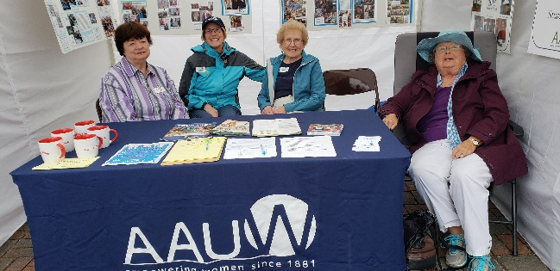

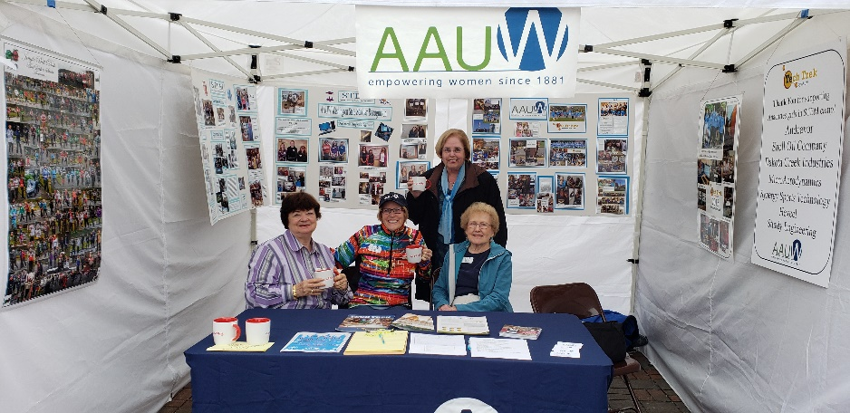Ora Jonasson arrived about 9 o’clock, but because traffic was low, we were able to persuade her to go home as soon as Don was finished with his Market shopping. Linda Hendrick arrived about 11:30, as did our Santa Claus John O’Clock.  Linda accompanied John on a tour of the market to stir up interest for the Jingle Bell Dash and eight flyers for the Dash were distributed and three people signed up for the event. John looked great in his brand new Santa outfit, and Linda, in blue, was a charming elf. John left after his Santa work, and Linda joined Ginny and me in our booth.  Rosette and Homer returned about 2 to pick up all the equipment, supplies, etc., and with help from Linda and Bunny, they soon had our booth packed up and everything in the Dawsons’ vehicle. Homer helped put the canopy, chairs, etc., in Bunny’s garage, where the canopy top is drying, draped over the chairs. One person signed up to become a potential member; she was very interested in attending the September meeting.

A very nice part of the day was when one of the 2010 STEM girls, stopped to thank AAUW for supporting her and giving her so much encouragement.  She was also a STEM participant in 2014. She is attending George Fox University in Oregon, where she is majoring in computer science.  It was such a pleasure to talk with her. Many thanks to all for helping to make the day a success.

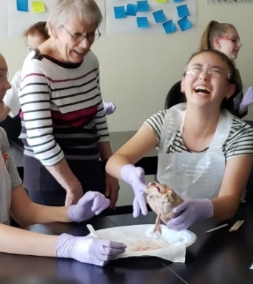

AAUW member, Jessica Koeberle, spends a time with a Tech Trek student who is dissecting a pig heart. Don’t miss the presentation given by Tech Trek students at the October meeting.