



Volume 35 Number 11

July 2018

**Anacortes Agent**



The 2018 LAF barbeque is scheduled for Sunday, the 21st of July, starting at 4 p.m., at the home of Lonny and Bunny Heiner, 804 K Avenue, Anacortes.  Please note the early date this year – this event has been in August in past years.  The main course will be contributed by the Heiners and the Dawsons.  Members are asked to contribute a side dish or a dessert.  The proceeds from this event go to the AAUW Legal Advocacy Fund (LAF). Admission is $25.00 per person or $40.00 for two.

The Legal Advocacy Funds works at the national level to challenge sex discrimination in the workplace and in higher education.  Unfair pay, pregnancy discrimination, sexual harassment, sexual assault, and violations of Title IX of the Education Amendments of 1972 are issues that many women and men face today.  LAF addresses these barriers by informing people of their rights and by assisting people who are using the legal system to seek justice and change.

Make your check out to AAUW-LAF and mail it to AAUW, P.O. Box 503, Anacortes, Washington 98221. **Please let Bunny know if you are coming or not by the 11th** of July. You can call her at 360-293-4120 or e-mail her at [bunnyheiner@gmail.com](mailto:bunnyheiner@gmail.com).  We hope to raise at least $500.00 at this event so that we may designate a branch member in honour of our contribution.



**Please welcome new member, Eva Coley. jaclyncoley@yahoo.com**



**Patricia Griffith 7/4**

**Christina Hansen 7/10**

**Laura Jane Viverette 7/22**

**Judy Slajer 7/29**



If you are new to the Anacortes Branch of AAUW or feel your current directory photo no longer looks like you, contact Lonny Heiner at [leheiner@gmail.com](mailto:leheiner@gmail.com) for a photo appointment in July. The new directory comes out in September. If you have new contact information, please tell Bonnie Underwood at 360-293-4075 or [underwood31@comcast.net](mailto:underwood31@comcast.net).



Each year our branch publishes a photo directory which includes contact information for members, state and national website listings, meeting dates, and more. The cost of a directory is a benefit of the dues you pay and one way to keep the cost down is to ask local businesses for advertising. The cost is only $25 for a business card ad, $50 for a ½ page, or $100 for a full page. This will help us keep our dues costs down. Please help support our branch by soliciting ads this month. Contact Bonnie Underwood before August 15 with your advertising information.

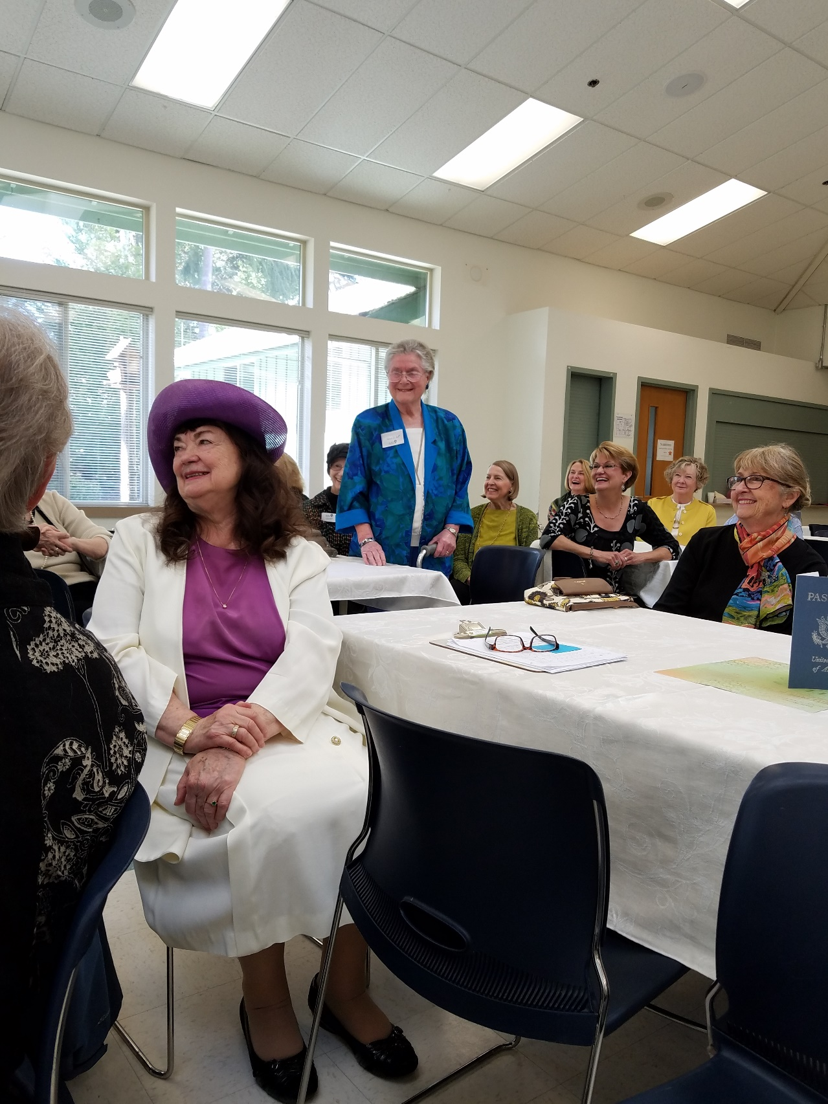**Pat Bell** is recovering from a broken hip and a broken arm, sustained in two separate accidents, and is doing well.  She is at Fidalgo Rehab, 1105 27th Street, Room 1.  Recently, she was able to walk aided only by a cane. This was her first walk since she broke her hip several weeks ago.  She is doing amazingly well and is in good spirits.