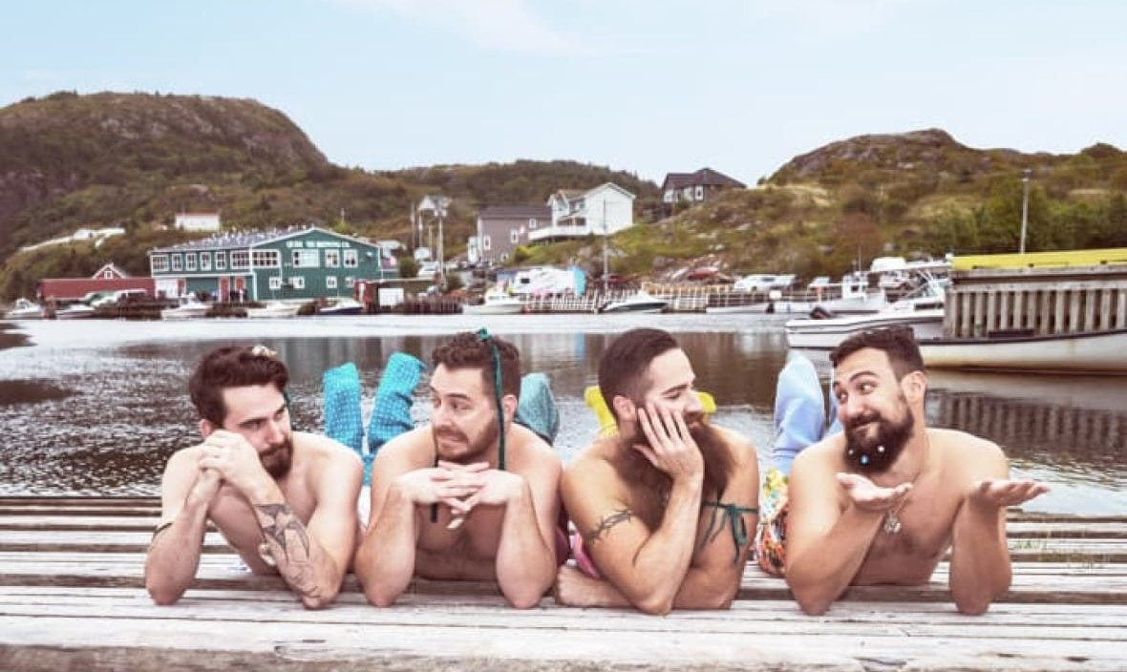
Mermen of Anacortes
AAUW Fundraiser

Purpose: To raise scholarship funds for local women through the Anacortes Branch of
The American Association of University Women (AAUW).
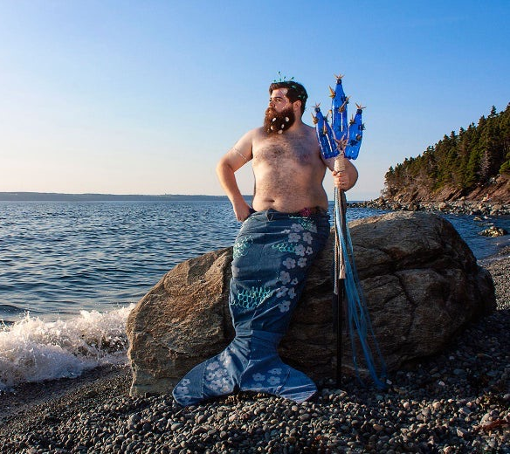
Venue: 4th of July Parade

Registration will open in April at:
https://anacortes-wa.aauw.net/events/fundraisers/

AAUW Anacortes is organizing a contest to select 12 Mermen to ride on a float in the 4th of July Parade and appear in a calendar that will be for sale online. Local men may enter individually or organize a group that must include at least one merman and may include mermaids and/or “merkids”.

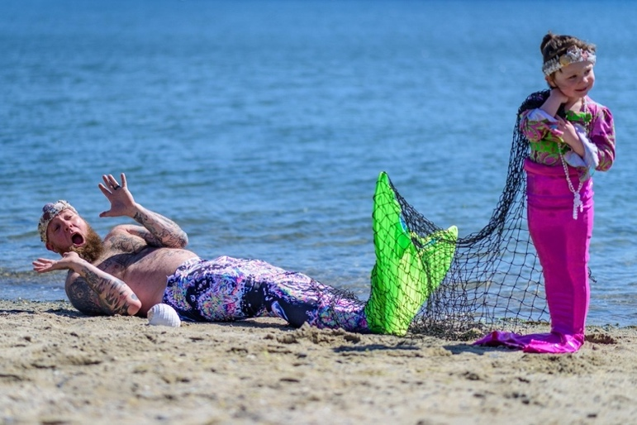
Participants must register online and submit a photo to our Anacortes branch. Costumes must be “suitable” for a family event. The AAUW Board will serve as judges. The photos should be high quality for publication in the calendar. Most likely the parade will require masks, but they are optional in the photos. If the parade is canceled, the calendars will still be available online.

There are three categories for entries: Sponsor, Individual/Group, and Donor

- Sponsored Category: Minimum donation $100. Local men may solicit donations from a business or organization that will be featured in the calendar as a sponsor. All sponsors will be listed on the front cover of the calendar. The top 6 fundraisers will be selected for the float and calendar. In the event of a fundraising tie, the committee will choose the most creative photo. Sponsors will be acknowledged on their Merman’s month.

- Individual/Group Category: Minimum donation $25. Local men may collect donations from family, friends and co-workers. The top 6 creative photos will be selected for the float and calendar.

- Donor: Minimum donation $50. Businesses or organizations may donate without entering the contest and be listed on the front cover of the calendar.

If it is a group entry, only one Merman may ride on the float, or the group may provide its own transportation. Each of the 12 winners will wear a sash in the parade displaying the month the winning photo will appear in the calendar.

All other entries may ride in the parade by providing their own transportation, i.e., truck, convertible, skates, skateboard, wheelchair, small boat, dinghy, etc.

If you collect additional funds after registering, mail the donation and it will count towards your total if it’s prior to the 6/12/21 deadline. Include the name of your sponsor or title.

Register online by June 12, 2021 at https://anacortes-wa.aauw.net/events/fundraisers/

Questions: aauwanacortes@gmail.com
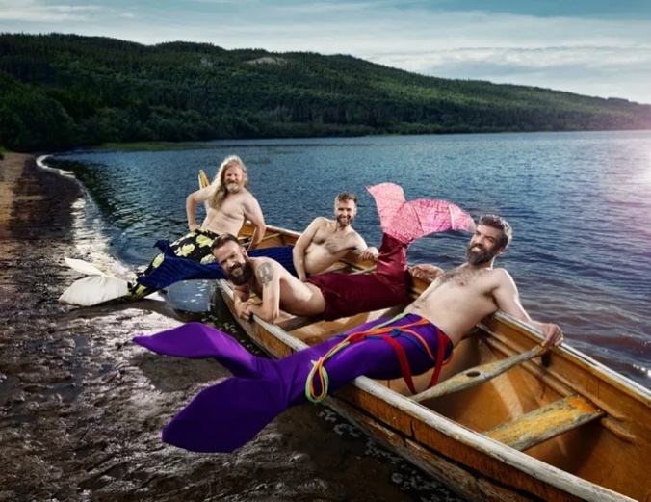
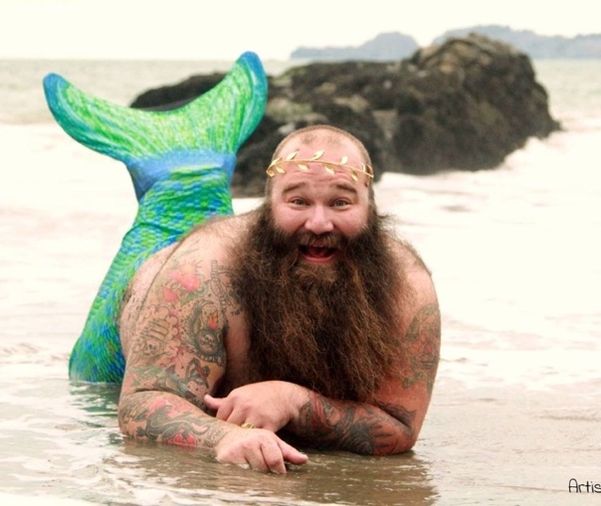

The Anacortes Branch of the American Association of University Women (AAUW) annually offers $2000 and $1000 scholarships to women who are in an undergraduate degree program, a vocational certification program, or planning to take courses beyond the undergraduate level in preparation for an advanced degree. The woman must either be an Anacortes High School graduate OR have resided on Fidalgo Island or Guemes Island for the last three years.

Photos are from Merb’ys Calendars - Newfoundland and Labrador Beard & Moustache Club

