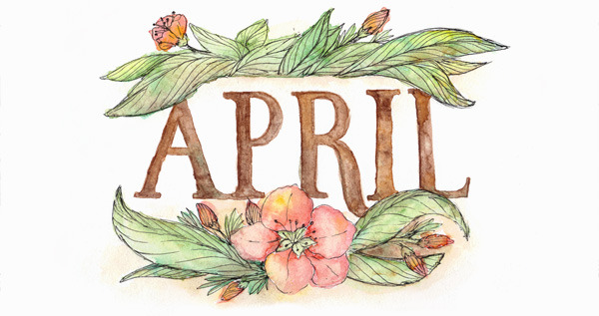****

Volume 35 Number 8

February 2018

**Anacortes Agent**

We are excited to host Amy Peloff, University of Washington professor,

speaking on

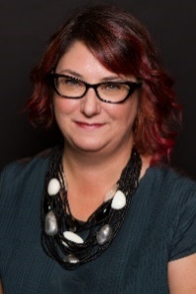 **Feminism and Popular Culture**

WHEN: 6:45 p.m. for coffee and conversation

7:00 p.m. on Thursday, April 12

WHERE: Anacortes Library Meeting Room – Invite a friend!

This presentation is part of Humanities Washington’s Speakers Bureau program, in which cultural experts discuss history, politics, music, philosophy, and everything in between at venues around the state. Humanities Washington sparks conversation and critical thinking using story as a catalyst, nurturing thoughtful and engaged communities across our state. It is a nonprofit 501(c)(3) organization. We are requested by the Bureau to have at least 30 people attend. Who will you invite?



In accordance with our by-laws, the following slate of officers has been proposed by the nominating committee. Elections will take place at the Annual Meeting in May. As we alternate the year in which we elect officers for the stability of the board, the following candidates are submitted for your consideration in 2018.

Co-Vice-President - Programs: JoAnn Satzinger (Tanna Baker will remain in office as Co-V.P.)

Vice-Presidents - Membership: Virginia Heiner and Virginia Kluth

Secretary: Rosemary Kaholokula



**Spring Tea Update**

Pat Bell was highlighted for her continued support of AAUW. Gift baskets were donated by members which contributed to our fundraising efforts. Tea, sweets, and savory bites were served by smiling members. Final numbers are not in, but it appears we made over $2,000.



Bonnie Underwood – 4/1

Robin Pestarino – 4/22



**AAUW March Board Meeting – February 26, 2018 at 7:00 p.m.**

**Present**: Tanna Baker, Terri Bawden, Bunny Heiner, Linda Hendrick, Sandy Huggins, Nelle Jacobson, Ora Jonasson, Karen Maughan, Robin Pestarino, JoAnn Satzinger, Megan Taylor, Bonnie Underwood

Robin called the meeting to order at 7:00 p.m. The minutes of the February meeting were approved. Linda presented a financial report which included an additional $590 for tea tickets since our last report. It was noted that she will need to have four $100 bills for our March meeting to give as awards to the middle school students. Linda reported that we do not have to file tax reports; paperwork for national will be turned in by March. Bunny was granted permission to open all mail from the Post Office Box to direct it appropriately.

**Program**: Rosette has arranged for a navy pilot as our STEM speaker; she is hoping that additional women will attend from the naval base. We will award four middle school students and give three $1000 scholarships to AHS students. Bunny will set up coffee at 6:15 for the meeting and Linda will bring a vegetable tray. Robin, Ora, Bunny and Nelle will bring cookies and Karen is sending brownies. Amy Peloff, from the Washington Speakers’ Bureau, will be our April speaker. We are committed to having a minimum of 30 people attend. Posters will be posted following the March meeting.

**STEM**: Rosette reported that we hav16 girls nominated from Skagit Valley schools in addition to AHS students. All are excellent candidates with financial needs, some with minimal parental support. To date we have only $8000; board members were encouraged to find additional financial support from businesses. Rosette is arranging interviews and will post dates in the March newsletter to find additional people to help interview at the schools. Beth will conduct AHS interviews at the library. Additionally, we are seeking room monitor volunteers (must be at least 21); a nominal stipend is offered. Camp dates are July 8-14 at SPU; July 15-21 at SPU; July 29-August 4 at Eastern.

**Website**: Linda reported that she has mastered including program information on our website. Terri offered to show her how to add an attachment. Bonnie was asked to include the website address in the newsletter.

(Continued on next page)

**Membership**: Sandy reported that we have no changes to our membership which remains at 47.

**Scholarship Tea**: Bunny has contacted all our members and filled most positions. Robin volunteered to chair the event; Bonnie will get the notebook to her. Terri will oversee the gift baskets. Bonnie will add the website and program information to the programs/ table decorations. Posters and tickets will be available at the March meeting. Robin will help transport the supplies stored at Bunny’s for Friday set-up. Gift basket donations will be set at $5 for 1 or $20 for 5.

**Scholarship**: Terri continues to wait for grant information from Albertson’s. To date she has not received any completed, qualified applications, but she anticipates more in March.

**Nominating**: Ora will seek candidates for Secretary, a Co-VP for Programs and VP of Membership.

**Other**: Tanna announced that SWIC is hosting “Take Back the Night” on April 27; she will provide information for the April newsletter. Robin’s term on the state board in over; she encouraged us to consider participating at the state level.

The meeting adjourned at 8:20 p.m.

Respectfully submitted, Bonnie Underwood, Secretary

**General Meeting Minutes – March 8, 2018**

Present: Tanna Baker, Terri Bawden, Barbara Benson, Jane Crannell, Rosette Dawson, Margaret Frey, Bunny Heiner, Linda Hendrick, Judy Higgins, Sandy Huggins, Ora Jonasson, Ginny Kluth, Beth Menaghan, Erika Shaw, Megan Taylor, Bonnie Underwood

The meeting was opened by Robin at 6:52 p.m. She introduced Tanna, who spoke about the upcoming tea and speaker. Beth followed with a brief overview of the Jingle Bell Dash and the roll that event plays in raising money for STEM awards. Beth then awarded four 8th grade students with $100 awards for science and math. Each recipient spoke briefly. Two of the three high school scholarship winners received certificates of recognition. Each will receive a $1,500 scholarship mailed to their college or university.

Rosette introduced our speakers from the Whidbey Island Naval Station: Lt. Caitlin Polini and Lt. Anna Middleton. Both spoke about their career paths, current roles in the military, and highlights of their military careers. Following questions from the audience, the program ended at 7:52 pm.

Robin called the business meeting to order at 7:55. Linda announced the importance of filling out a “Gift-in-Kind” donation form and reminded members to turn them in after the tea. The minutes of the February general meeting were approved. A request for dorm monitors for PLU Tech Trek camp was announced and the meeting was closed at 8:10 p.m.

Respectfully submitted,

Bonnie Underwood, Secretary

**Anacortes AAUW -** Gift–in Kind Acceptance Form

When members give of their own time, item and/or money, the organization would appreciate having record of that contribution.  Donors may also want a personal record, perhaps for tax purposes. We feel our members give great value to Anacortes AAUW and it should be documented. This form is for donations that are not reflected in checks given to AAUW. Drawing baskets, food, time are some examples of gifts-in-kind.

 Donor Name (Individual or Business): ___________________________________

Contact Name (if Business): __________________________________________

Street Address: ____________________________________________________

City:  ____________________________________________________________

State: ______       Zip: ____________

Date: ­­­­­­­­­­­­­­­­­­­­­­­­­­­­________________________________

Phone: _______________________________

Email: ___________________________________________________________

Program Gift: (STEM, Tech Trek , etc.)  _________________________________

Date Gift Received:  ____________

Value of Gift: $   _______________

How was value determined? (by donor or by recipient?) _________________________

Please retain for your records and send a copy to the Finance Officer for retention: FO.AnacortesAAUW@gmail.com